**2025 SUMMER**

**CONCERTS IN THE PARK**

Sponsored by: Bedford Parks & Recreation Department

Bedford’s 275th Anniversary Committee

***BEDFORD VILLAGE COMMON @ Gazebo***

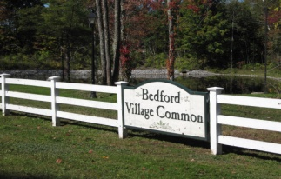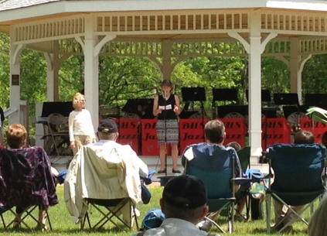

**Wednesday evening @ 6 PM**

June 25 “Bel Airs” (Doo Wop Vocal Quintet)

July 2 “The Rampage Trio” (Family Friendly Classic Rock)

July 9 “North River Music” (Americana Band)

July 16 “Knock on Wood” (Acoustic folk-rock duo)

July 23 “Endless Skies Band” (

July 30 “Manchester Community Music School”

**FREE Concerts - Pack your coolers, bring a picnic dinner, your lawn chair or blanket, and put on your dancing shoes!**

**Popular local musicians are flocking to the Bedford Village Common Park this summer for a live outdoor concert series in June, July. The Gazebo stage will be rocking most Wednesday evenings at 6 PM with select talented artists jamming out all summer long.**

REV: 1-a3-2025